# Numerical Optimization of Equally Distributed Managers for Teams – aka Mix the Managers

***By Nate Pollesch and Dale Hoff***

Random sampling to create teams with optimal connectivity in a hierarchy has been shown to outperform more complicated greedy team building algorithms. In addition, random sampling is much faster than other grouping algorithms. Therefore, numerical optimization of realizations of randomly sampled teams is computationally feasible to determine further optimal team configurations. In this exercise, the objective of *evenness* among teams based on manager level has been added.

## Pielou’s Evenness

Evenness is quantified here by Pielou’s Evenness index[1], a measure that considers distribution among ‘species’ for each team. It ranges in value between 0 and 1, with 1 being perfectly even and 0 as perfectly uneven (i.e. all of a single species). There is no formal science to support that managers at different management levels are in fact different species. So, species in this case refers to management level, with the following levels and representation,

Figure : Distribution of management levels

1. Branch level (87, 50%)
2. Center level (32, 19%)
3. Office level (39, 23%)
4. Headquarters Level (14, 8%)

100001 randomly generated management teams were created and using Monte Carlo numerical optimization, the team with the largest total evenness was chosen as the best team. This resulted in an Total Evenness value of 10.89 (KL=0.499).

Teams generated using maximum total evenness as the objective function are shown in Figure 2. Figure 3 shows the total evenness values for each of the 100001 realizations. Table 1 shows the actual names of the teams which are also included in an attached spreadsheet *teamsEV.xlsx.*

## Kullback-Liebler Divergence

Kullback-Liebler[2] divergence is a measure of dissimilarity between probability distributions. For this example, it was modified so that the empirical distribution of managers across levels was compared to the actual distribution of managers at the meeting in each team. As such, a team that had percentages as close as possible to the population percentages (shown in Figure 1) would have minimal KL divergence. The theoretical minimum for KL divergence is 0, however, given the constraint on team sizes and because as much as they try, managers cannot fractionally divide their persons, a KL divergence of 0 is not possible in this system.

100001 realizations using minimum total KL divergence as the objective were run (results in Figure 4). The optimal team configuration had a total KL Divergence of 0.506 (Total Evenness 10.87). This resulted in the distribution for teams shown in Figure 5. The teams corresponding to the KL optimized configuration are shown in Table 2 and included in the attached spreadsheet *teamsKL.xlsx*

## So, which teams then?

Using both strategies to optimize teams for an even distribution of managers from each of the management levels led to similar results. The optimization using Evenness as the metric yielded better results and was significantly faster computationally (note: almost no effort was put into optimizing the numerical algorithms at this point). A quick visual check of Figures 2 and 4 will reveal that in each configuration, there was a single team without a manager from HQ and two teams with two managers from HQ. This is nearly optimal with respect to HQ managers, since there are 14 to be distributed among 13 teams.

This optimization was done based solely on the categories of management level and no quantification of their locality within the ORD structure was taken into account. Therefore, it is recommended that teams are looked at post-hoc to 1) Swap an HQ manager from one of the teams with two to the team with none and 2) Visually inspect teams to ensure we don’t have all of GLTED on a single squad with their direct line management (that would be great, of course, but we are trying to bridge the Bacon’s and build connectivity here).

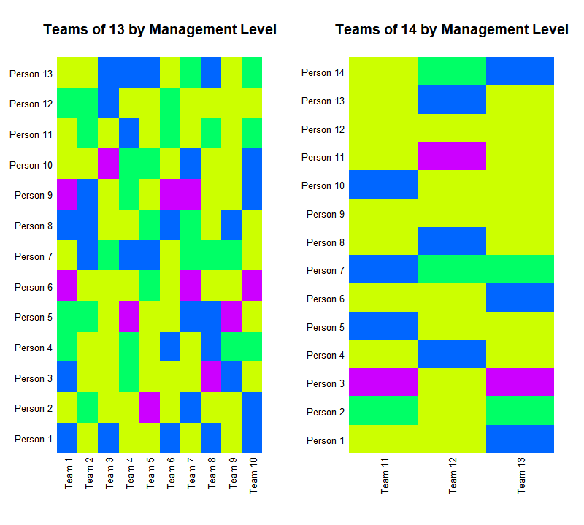

Figure : Evenness optimized team visualization colored by management level (see Figure 1).. Total evenness 10.89 with a corresponding total KL of 0.499.

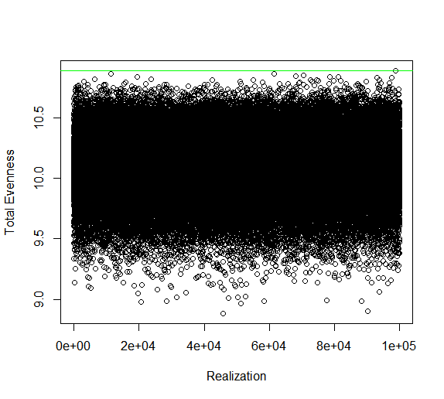

Figure : Total Evenness Scores for 100001 random team realizations. Green line is optimal with total Evenness of 10.89

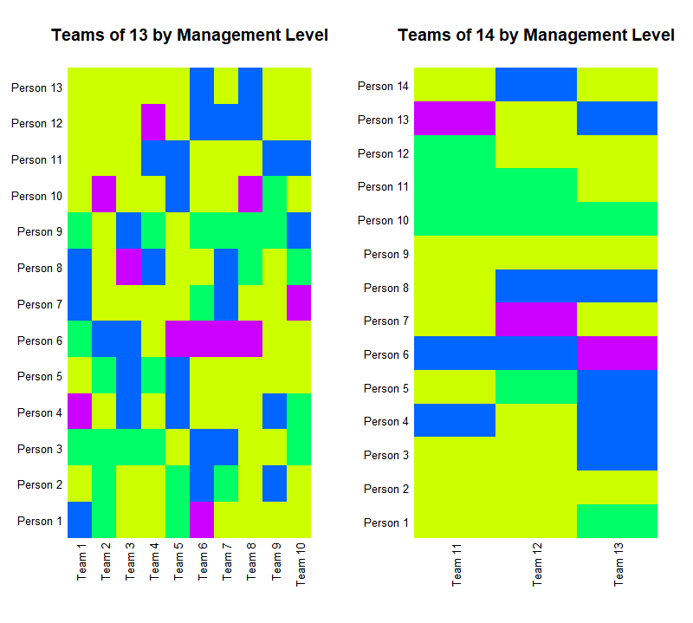

Figure : KL Optimized team visualization colored by management level (see Figure 1). Total evenness 10.87 with a corresponding total KL of 0.5.06.

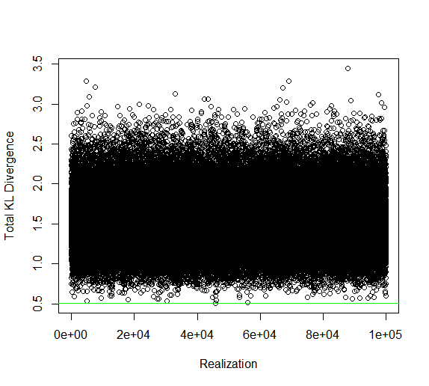

Figure : Total KL Scores for 100001 random team realizations. Green line is optimal with total KL of 5.06

|  |  |  |  |  |  |  |  |  |  |  |  |  |  |
| --- | --- | --- | --- | --- | --- | --- | --- | --- | --- | --- | --- | --- | --- |
| 1 | Jerry Blancato - 3 | Richard Shores - 1 | Jeff Sutton - 3 | Alan Vette - 2 | Yvonne Murphy - 2 | Bruce Rodan - 4 | Chris Weaver - 1 | Vacant - CESER-GCRD-IO - POS Chief - 3 | David Dunlap - 4 | Joel Hoffman - 1 | Jane Ellen Simmons - 1 | Kelly Dipolt - 2 | Martin Lawrence - 1 |
| 2 | Ravi Subramanian - 1 | John Vandenberg - 2 | Mike Hughes - 1 | Peter Celone - 1 | Lara Phelps - 2 | Gene Stroup - 1 | Wayne Cascio - 3 | Stephen Thompson - 3 | Claudette Mitchell - 3 | Matthew Hopton - 1 | Heather Cursio - 2 | Kris Thayer - 2 | Elin Ulrich - 1 |
| 3 | Tom Speth - 3 | Tammy Stoker - 1 | Janet Nestlerode - 1 | Sigmund Degitz - 1 | Emily Snyder - 1 | Ian Gilmour - 1 | Maria Doa - 2 | Surender Kaushik - 1 | Andre Reinhart - 1 | Lou D'Amico - 4 | Sid Hunter - 1 | Bill Fisher - 3 | Dale Hoff - 3 |
| 4 | Amy Fox - 1 | Jeffrey Morgan - 1 | Regan Murray - 2 | Maggie Lavay - 2 | Jennifer Orme-Zavaleta - 4 | Rebecca Dodder - 1 | John Steenbock - 3 | Ted Dewitt - 1 | Lisa Baxter - 2 | Pat Vaughan - 2 | Sandhya Parshionikar - 3 | Barbara Bergen - 1 | Brian Kleinman - 3 |
| 5 | Jeff Szabo - 1 | Mark McPherson - 4 | Marty Chintala - 1 | Jeremy Dunne - 1 | Jonathan Pressman - 1 | Kirk Scheckel - 2 | Kacee Deener - 3 | Wayne Munns - 2 | Mark Higuchi - 1 | Sean Dowd - 2 | Michael Gonzalez - 1 | John Mckernan - 1 | Tia Groves - 3 |
| 6 | Michael Boucher - 3 | Brent Johnson - 1 | Eric Burman - 1 | Nancy Broom - 3 | Caroline Stevens - 1 | Todd Baker - 1 | Gerald Brunson - 1 | Samantha Jones - 3 | Susan VanDrunick - 4 | Michael Hornung - 1 | Shawn Ryan - 2 | Alice Gilliland - 2 | Lisa Smith - 1 |
| 7 | John Cowden - 1 | Deb Heckman - 3 | Lindsay Stanek - 1 | Peter Egeghy - 1 | Stephen Musson - 3 | Bryan Hubbell - 4 | Mark Bagley - 2 | Beth George - 2 | Mike Slimak - 4 | Monica Linnenbrink - 3 | Andrew Hotchkiss - 1 | Dannelle Lobdell - 1 | Ann Keeley - 2 |
| 8 | Van Anderson - 3 | Paul Ringold - 1 | Jeff Fristhen - 4 | Missy Milbeck - 3 | Tom Scheitlin - 3 | David Burden - 1 | Lynn Flowers - 2 | Tim Gleason - 1 | Mary Hautajarvi - 1 | Alan Thornhill - 1 | Myriam Medina-Vera - 2 | Adam Biales - 1 | John Sykes - 3 |
| 9 | Megan Mehaffey - 1 | Jackie Rosati - 1 | Reeder Sams - 3 | Tom Connolly - 2 | Chris Robbins - 4 | Britta Bierwagen - 1 | Mary Ross - 2 | Tim Watkins - 3 | Eric Villegas - 1 | Dennis Timberlake - 1 | Mike Elovitz - 1 | Rick Wilken - 1 | Patricia Palmer - 1 |
| 10 | Andy Gillespie - 3 | Eric Hubbell - 3 | Naneka Mason - 1 | Doug McKinney - 2 | Ana Rappold - 1 | Dale Perry - 4 | David Bolgrien - 1 | Barbara Glenn - 1 | Glenda Noel - 3 | Kay Holt - 3 | Mike McDowell - 2 | Viktor Morozov - 1 | Bhagya Subrsmanian - 2 |
| 11 | Tanya Spero - 1 | Brian Schumacher - 2 | Fred Hauchman - 4 | Marguerite Kosoff - 1 | Rusty Thomas - 3 | Donna Schwede - 1 | James Gentry - 3 | Yongshan Wan - 1 | Mike Hiscock - 1 | Annette Guiseppe-Elie - 3 | Will Yelverton - 1 | Betty Kreakie - 1 | Janice Lee - 1 | Kathie Dionisio - 1 |
| 12 | Jim Markwiese - 1 | Beth Owens - 1 | Chris Saint - 1 | Kathryn Barton - 3 | Stuart Willison - 1 | Stephanie Padilla - 1 | Amar Singh - 2 | Katherine Saterson - 3 | Dan Chang - 1 | Steve Van Horn - 1 | Liz Blackburn - 4 | Eunice Varughese - 1 | Ron Hines - 3 | David Diaz-Sanchez - 2 |
| 13 | Bill Russo - 3 | Mike Devito - 2 | Carolyn Hubbard - 4 | Susan Burden - 1 | Jeanne Scott - 1 | Greg Sayles - 3 | Maureen Gwinn - 2 | John Johnston - 1 | Valerie Blank - 1 | Vacant - CCTE-SCDCD-DMMB - Branch Chief - 1 | Angela Hadley - 1 | Vickie Wilson - 1 | Kerry Loar - 1 | Ashley Ramsey - 3 |

Table : Teams from Evenness Optimization

Table : Teams from KL Optimization

|  |  |  |  |  |  |  |  |  |  |  |  |  |  |
| --- | --- | --- | --- | --- | --- | --- | --- | --- | --- | --- | --- | --- | --- |
| 1 | Stephen Thompson - 3 | Alan Thornhill - 1 | Brian Schumacher - 2 | Mike Slimak - 4 | Rick Wilken - 1 | Mark Bagley - 2 | Missy Milbeck - 3 | Michael Boucher - 3 | Heather Cursio - 2 | Eric Burman - 1 | Elin Ulrich - 1 | Jeff Szabo - 1 | Jonathan Pressman - 1 |
| 2 | Bhagya Subrsmanian - 2 | Mike McDowell - 2 | Kris Thayer - 2 | Joel Hoffman - 1 | Maria Doa - 2 | John Sykes - 3 | Matthew Hopton - 1 | Barbara Glenn - 1 | Amy Fox - 1 | David Dunlap - 4 | Chris Saint - 1 | Andre Reinhart - 1 | Ted Dewitt - 1 |
| 3 | Dannelle Lobdell - 1 | Marguerite Kosoff - 1 | Amar Singh - 2 | Glenda Noel - 3 | Rusty Thomas - 3 | Jeff Sutton - 3 | Sigmund Degitz - 1 | Bryan Hubbell - 4 | Tom Scheitlin - 3 | Ana Rappold - 1 | Marty Chintala - 1 | Mark Higuchi - 1 | Mike Elovitz - 1 |
| 4 | Vacant - CCTE-SCDCD-DMMB - Branch Chief - 1 | David Bolgrien - 1 | Alan Vette - 2 | Chris Weaver - 1 | Kelly Dipolt - 2 | Dan Chang - 1 | Sid Hunter - 1 | Kay Holt - 3 | Tom Connolly - 2 | Mike Hiscock - 1 | James Gentry - 3 | Susan VanDrunick - 4 | Tammy Stoker - 1 |
| 5 | Beth George - 2 | Doug McKinney - 2 | Adam Biales - 1 | Vacant - CESER-GCRD-IO - POS Chief - 3 | Deb Heckman - 3 | Dale Perry - 4 | Valerie Blank - 1 | Michael Hornung - 1 | Barbara Bergen - 1 | Claudette Mitchell - 3 | Jerry Blancato - 3 | Will Yelverton - 1 | Megan Mehaffey - 1 |
| 6 | Liz Blackburn - 4 | Monica Linnenbrink - 3 | Dale Hoff - 3 | Stuart Willison - 1 | Rebecca Dodder - 1 | Mark McPherson - 4 | John Vandenberg - 2 | Susan Burden - 1 | Sean Dowd - 2 | Viktor Morozov - 1 | Ian Gilmour - 1 | Andy Gillespie - 3 | John Steenbock - 3 |
| 7 | David Burden - 1 | Mike Devito - 2 | Tim Watkins - 3 | Janice Lee - 1 | Janet Nestlerode - 1 | Chris Robbins - 4 | Nancy Broom - 3 | Eric Hubbell - 3 | Pat Vaughan - 2 | Betty Kreakie - 1 | Tim Gleason - 1 | Tom Speth - 3 | Eric Villegas - 1 |
| 8 | Jeffrey Morgan - 1 | Angela Hadley - 1 | Surender Kaushik - 1 | John Johnston - 1 | Todd Baker - 1 | Fred Hauchman - 4 | Peter Celone - 1 | Lara Phelps - 2 | Maggie Lavay - 2 | Lou D'Amico - 4 | Caroline Stevens - 1 | Katherine Saterson - 3 | Wayne Cascio - 3 |
| 9 | Eunice Varughese - 1 | Kacee Deener - 3 | Britta Bierwagen - 1 | Kathryn Barton - 3 | John Cowden - 1 | Ravi Subramanian - 1 | Jeremy Dunne - 1 | Gerald Brunson - 1 | Regan Murray - 2 | Alice Gilliland - 2 | Ashley Ramsey - 3 | Jackie Rosati - 1 | Paul Ringold - 1 |
| 10 | Beth Owens - 1 | Stephanie Padilla - 1 | Maureen Gwinn - 2 | David Diaz-Sanchez - 2 | Kathie Dionisio - 1 | Lisa Smith - 1 | Carolyn Hubbard - 4 | Myriam Medina-Vera - 2 | Sandhya Parshionikar - 3 | Jane Ellen Simmons - 1 | Van Anderson - 3 | Dennis Timberlake - 1 | Vickie Wilson - 1 |
| 11 | Yongshan Wan - 1 | Tanya Spero - 1 | Brent Johnson - 1 | Bill Russo - 3 | Donna Schwede - 1 | Samantha Jones - 3 | Steve Van Horn - 1 | Mike Hughes - 1 | Emily Snyder - 1 | Lisa Baxter - 2 | Shawn Ryan - 2 | Ann Keeley - 2 | Bruce Rodan - 4 | Michael Gonzalez - 1 |
| 12 | Jim Markwiese - 1 | Lindsay Stanek - 1 | Martin Lawrence - 1 | Jeanne Scott - 1 | Wayne Munns - 2 | Brian Kleinman - 3 | Jeff Fristhen - 4 | Tia Groves - 3 | Patricia Palmer - 1 | Kirk Scheckel - 2 | Mary Ross - 2 | John Mckernan - 1 | Kerry Loar - 1 | Bill Fisher - 3 |
| 13 | Yvonne Murphy - 2 | Andrew Hotchkiss - 1 | Stephen Musson - 3 | Reeder Sams - 3 | Ron Hines - 3 | Jennifer Orme-Zavaleta - 4 | Richard Shores - 1 | Greg Sayles - 3 | Peter Egeghy - 1 | Lynn Flowers - 2 | Mary Hautajarvi - 1 | Naneka Mason - 1 | Annette Guiseppe-Elie - 3 | Gene Stroup - 1 |

1. Pielou’s evenness, $J$, is a measure used to assess biodiversity. $J = H'/ln(S)$ where $H'$ is Shannon Weiner diversity and $S$ is the total number of species in a sample, across all samples in dataset. In this case, species are managers at different levels, so there are four observable species at the meeting.
2. Kullback-Liebler Divergence is defined as $\sum_{x∈X}{P\left(x\right)\log\left(\frac{P\left(x\right)}{Q\left(x\right)}\right)}$ where $P(x)$ and $Q(x)$ are the probability distributions being compared. Since $Q(x)$ is the population proportion of managers it does not equal 0. So, KL is defined in this exercise.